**CENWP-OD-B 13 September 2023**

**MEMORANDUM FOR THE RECORD**

**SUBJECT: 23BON091 MFR AFF Valve 15 Salmonid Mortality**

On the morning of 13 September, Columbia River Inter-Tribal Fish Commission (CRITFC) Biologists notified Bonneville Project Biologists of one salmonid mortality found on the Valve 15 trash rack in the Adult Fish Facility (AFF). The fish was scanned for PIT tags, inspected, and returned to the river.

1. Species – Chinook Salmon (*Oncorhynchus tshawytscha)*
2. 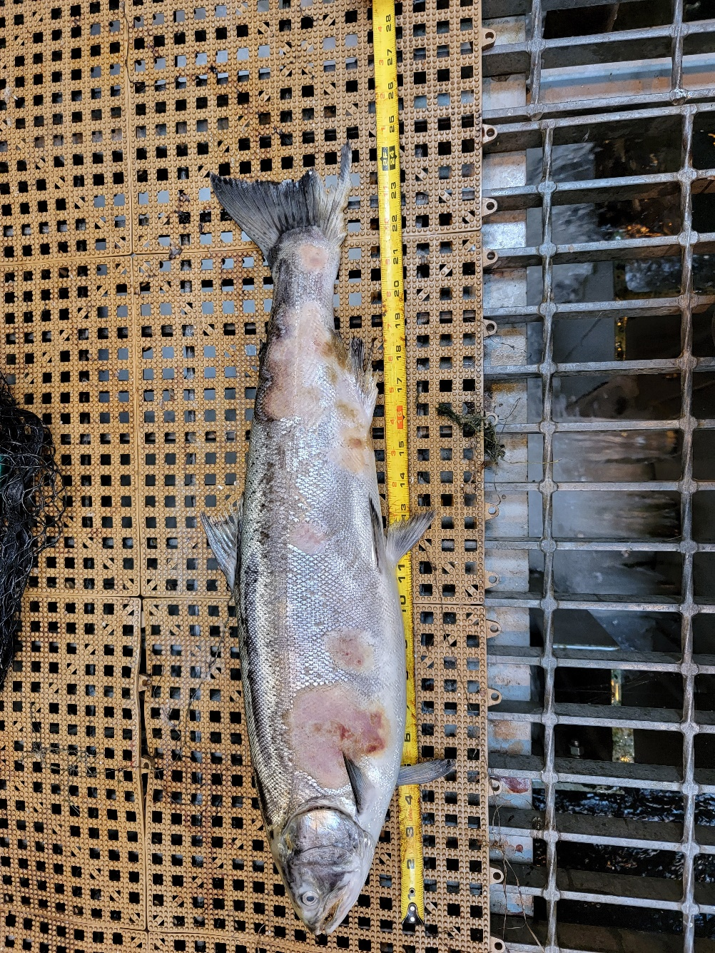Origin – Unknown
3. Length – 62.9 cm
4. Marks and tags – No PIT tags
5. Marks and Injuries found on carcass – General decay.
6. Cause and Time of Death – Unknown
7. Future and Preventative Measures – None

Sincerely,

Bonneville Project Fisheries